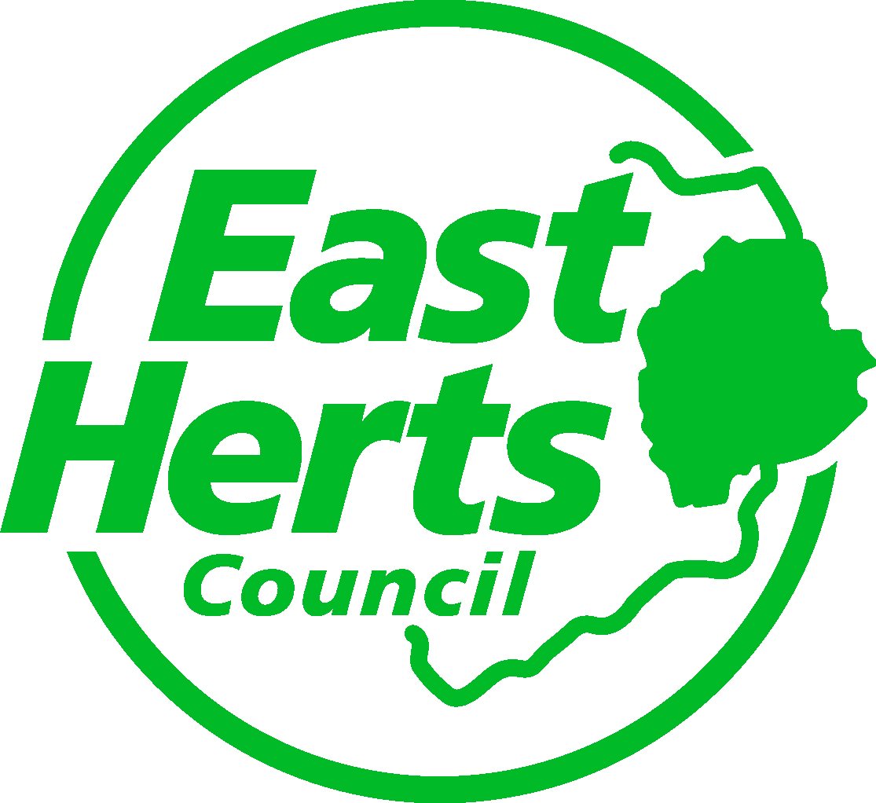 | FREQUENTLY ASKED QUESTIONS

What do I have to include with my application?
Please ensure that you enclose all relevant paperwork with your application form, or if applying online that you also send all relevant paperwork, including:

- Name and contact details of main contacts, including chair, treasurer and secretary, in your organisation
- Written endorsement by the East Herts Councillor representing the ward from where most of your clients will come
- Bank statement showing current balance
- Copy of constitution / set of rules or charity commission number
- Copy of child protection policy (if your organisation works with children)
- Evidence of planning permission (if required)
- Two quotes for building work and cost estimates for large items of equipment

You may also wish to include letters of support, feedback from your consultation and any other information that supports your business case and how you will take forward the outcome(s) you ticked. If this paperwork is not received by the deadline, your application will not be processed.

What type of projects is the council interested in funding?

We are interested in funding projects that take forward our priorities that promote health and wellbeing of residents of East Hertfordshire. Your application must evidence that the grant requested will directly or, in the case of improvements to buildings or green space, indirectly support at least one of the priorities listed in our grants policy. We will fund volunteer training as long as you can show how it promotes health and wellbeing.

The new priority around widening access is interesting. What would you fund under that?

This priority is about being more inclusive and supporting school-age children and young people, especially those who are vulnerable or disadvantaged in some way, to more easily take part in sports and cultural activities. For example, organisations can apply for a bursary to pay for costs of transport or to offer a free annual membership to children from low income families, subject to evidence of financial need..

Who may apply?
Properly governed voluntary, or not-for-profit organisations that are proposing projects that benefit the wider community in East Herts, including Buntingford, Sawbridgeworth, Hertford, Bishop’s Stortford, Ware and the many rural villages.

Organisations that are proposing large-scale projects related to buildings or green spaces must already have most of the money for their project and to be applying to the council at the end of their fundraising campaign.

What does the application process involve?

Organisations must submit their request for funding by the stated deadline on an online application form and attach all the required paperwork. If you do not provide a strong argument for funding you will not be awarded a grant. You must obtain endorsement from the East Herts Councillor representing the area where the project is to happen or where most of the beneficiaries are from. Applications to be emailed to Grants.Admin@eastherts.gov.uk

How do I obtain endorsement from my East Herts Councillor for my application?

To find out who this is click on the link: https://www.eastherts.gov.uk/article/35546/Find-your-Councillor
What is the maximum grant?
Up to £8,000 is available to fund improvements to buildings and open spaces. Up to £3,000 is available to fund all other projects but please be aware that the maximum grant is only available for projects that run for 6 weeks or longer and will clearly result in positive changes to behaviour.

When are we eligible to apply for a grant again, after being successful?

You are eligible to reapply once you have delivered or completed your existing project or activity.
What will not be funded?
- Medical equipment
- Promotion of a particular religion or political belief
- A service the state is obligated to provide
- Land or building where ownership or a lease is not yet established
- Projects that will take longer than a year to complete
- VAT that you can recover
- Projects that have already started before the Council has made a decision on the application
- Work on a building or outdoor space if the freehold or a lease lasting longer than 5 years is not in place or if the relevant planning permissions are not in place

Would it be possible for a grant to be back dated for money the club pays out to be reimbursed if the funding bid is successful?

No, the council does not fund retrospectively for projects or activities that have already taken place.

How will we assess your application?
We will closely assess the business case and evidence you provide for why we should fund your proposed project and the health and wellbeing outcomes it will address. Each application will be assessed on its own merit against carefully designed criteria. The funds available will be allocated to those applications with the highest scores. Applications will not be considered after the closing deadline. The criteria that applications will be judged on are as follows

- Whether the project is being delivered in a disadvantaged area of East Herts
- Number of people that will benefit
- Evidence that project/activity will realistically take forward the health and wellbeing outcome(s) that you have selected
- Evidence that consultation has taken place and the results support your project or activity
- Evidence of financial need

We will also consider whether you are contributing any funds toward the project

Applications that achieve less than 50% of the total score will not be funded. Projects that score low compared to others but that officers consider to have potential may be funded if the applicant agrees to certain conditions proposed by East Herts Council.

What do we mean by evidence?

This is facts or information that supports your proposal and proves that there is a problem. It could range from national or local statistics, waiting lists to feedback from public meetings and testimonials. It forms part of your business case. The more background information you provide the higher your score.

What do we mean by consultation?

Consultation is defined as activities undertaken for a set time period to seek opinions from a chosen group in order to reach a decision. The greater the level or amount of consultation that takes place, the higher the score the application will receive as long as the feedback supports your proposed actions. It is important to provide evidence of this type of work such as results from a questionnaire.

How do I receive my grant?
If your grant is successful we will confirm this via email no later than 8 to 10 weeks after the deadline. In the case of revenue funding, once we receive your reply agreeing to the terms and conditions, we will arrange payment directly to your bank account. Successful applicants of projects relating to work on a building or green space will be expected to complete the project within a year from the date on the award letter and then submit a claim form with all the relevant invoices showing evidence of expenditure. We will not release a grant in advance. Please note we do not make payments to individuals.

What happens if I sell the building?
Organisations wishing to dispose of buildings or equipment that have received a grant must seek the consent of the council. The council reserves the right to require repayment of the grant, in full, immediately following the disposal.

